Databases – written exam
Computer Science in English, 2nd year, 2020

I.
1. The 3rd normal form is a normalization rule obtained when the 2nd normal form is already checked, and any non-prime attribute of a relation is fully dependent on a key attribute, not on a any other non-primary key.
2. A ternary relationship set is a relationship set based on three entities. One example can be set on the relationship “borrow”, between a library member, a book and the library. In other words, in this relationship set, the library member borrows a book from the library.

II.
1. a. 3NF is satisfied since all non-prime attributes are fully dependent on a key attribute.
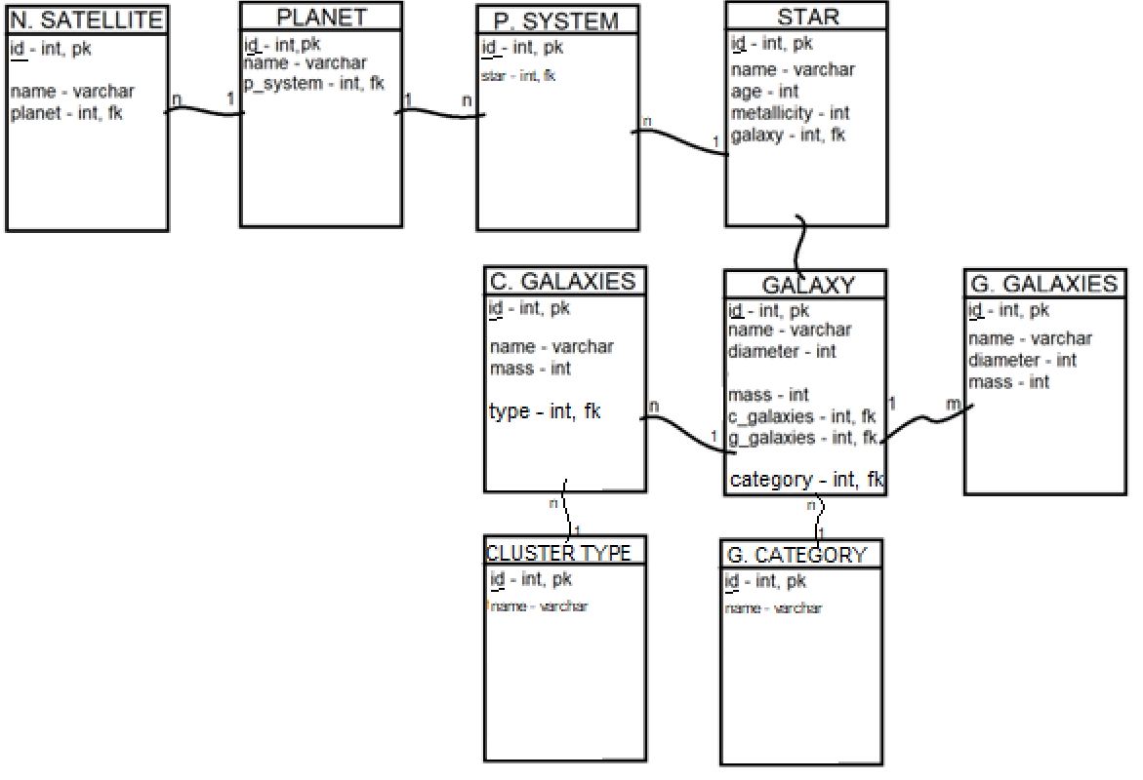
b.
CREATE TABLE NaturalSatellite (
id int primary key,
name varchar(30) not null,
planet int references Planet(id)
)

CREATE TABLE Planet (
id int primary key,
name varchar(30) not null,
planetary_system int references Star(id)
)

2.
a.
SELECT S.name, S.age
FROM Star S INNER JOIN Galaxy G on S.galaxy = G.id
INNER JOIN PlanetarySystem PS on PS.star = S.id
INNER JOIN Planet P on P.p_system = PS.id
WHERE G.name = ‘Milky Way’ and (
(SELECT COUNT(*)
FROM Planet
WHERE p_system = PS.id) >= 5
OR
(SELECT COUNT(*)
FROM NaturalSatellite NS1 INNER JOIN Planet P1 on NS1.planet = P1.id
WHERE P1.p_system = PS.id) > 0
)
)

b. Type in T-SQL language then translate into relational algebra since it is easier.
T-SQL:
SELECT CG.name, G.name
FROM ClusterGalaxies CG NATURAL JOIN Galaxy G
WHERE CG.type = 2

Relational algebra:
π{ClusterGalaxies.name, Galaxy.name}
(
σ ClusterGalaxies.type = 2 (ClusterGalaxies * Galaxy)
)

III.
- a. returns (a1, b2) -> 2 tuples
b. one field can’t take two values at the same time -> 0 tuples
c. it uses union, not union all, so there will be no duplicates
both return the same tuples, 3 tuples
-> 3 tuples
d. first select statement -> first 4 tuples
second select statement -> first 4 tuples
first \ second -> 0 tuples
Correct answer/s: a, d

- The natural join mentioned is equivalent to a INNER JOIN on S1.F = S2.F.
F = 1 -> 1 join
F = 0 -> 4 joins
F = -1 -> 4 joins
4 + 4 + 1 = 9 records
Correct answer/s: d

- It will run into an error, since HAVING contains field D which is not specified in the GROUP BY, and further neither in SELECT.
Correct answer/s: e

- C field needs to start with the string “de” and can have any number of characters after. No C field starts with “de” -> 0 tuples.
Correct answer/s: b

- Tricky question
Correct answer/s: a

- If we take the example of an entity-relationship diagram, it can be used to describe the structure of the data, including the names, data types, and constraints of the columns in a table, as well as the relationships between different tables. It can also describe the consistency constraints, such as primary keys, foreign keys and other rules.
Correct answer/s: a, c, d

- In a DBMS, the buffer manager is responsible for managing the buffer cache, which is a portion of main memory. The buffer manager brings pages from the disk into the buffer cache, and also keeps track of the pages that are currently in the cache and the pages that have been modified.
Correct answer/s: b

- a. not necessary, they are not dependent
b. same as above
c. you can use HAVING only if you are using it with GROUP BY, not ORDER BY
d. not necessary, GROUP BY can exist without HAVING, but not the other way
Correct answer/s: e

- a. no repeating attributes => 1NF
b. the non-prime attributes are not functionally dependent on prime attributes ⬄ no non-prime attribute is dependent on any proper subset of any candidate key of the table; that is not the case, since there are {ID1, ID2} and {A} subsets of the candidate keys which determine the given dependencies
=> not 2NF
=> not >2 NFs
Correct answer/s: a

- Correct answer/s: b, c, d

- Correct answer/s: c

- The projection operator is used to select specific columns from a relation, it's a unary operator because it operates on one relation.

Correct answer/s: b

IV. E = (𝜎 ID = B1 AND A2='exam' AND B2='DB' (A×B)) * (𝜎C1=3 (C×D))
E1 := (𝜎 A2='exam' A)
E2 := (𝜎 B2='DB' B)
E3 := E1⨂ ID = B1 E2
E4 := (𝜎 C1=3 C) × D
E := E3 * E4
